Genomics of Drug Sensitivity in Cancer (GDSC)
Exploratory Data Analysis
HackBio AI for Genomics Internship
Team valine-asparagine-alanine
Uncovering drug response patterns, cancer-type sensitivity profiles, and genomic biomarkers of pharmacological outcome
Dataset: GDSC Public Repository
Objective
This notebook performs an exploratory analysis of the GDSC dataset to identify:
- Drug sensitivity patterns
- Cancer-specific therapeutic responses
- Highly selective anti-cancer drugs
- Genomic determinants of drug response
- Precision oncology insights
Scientific Background
The Genomics of Drug Sensitivity in Cancer (GDSC) project links:
- Cancer cell lines
- Genomic features
- Drug response measurements
The aim is to understand how tumour molecular profiles influence therapeutic sensitivity.
Dataset Overview:
The GDSC dataset contains 162,103 drug-cell line sensitivity measurements across 246 drugs, 737 cancer cell lines, and 30 TCGA cancer types. Each row represents a single drug tested on a single cell line, with the following key variables: The Key Variables in the Datasets include LN_IC50, AUC, Z_SCORE (sensitivity metrics); DRUG_NAME, TARGET, TARGET_PATHWAY (therapeutic agents); CELL_LINE_NAME, TCGA_DESC, Microsatellite instability Status (Cancer Models); and CNA, Gene Expression, Methylation (Omics).
Each column represent:
Columns | Description
COSMIC_ID | Unique Identifier on COSMIC
CELL_LINE_NAME | Name of cell line
TCGA_DESC | TCGA Code for cancer type
DRUG_ID | Drug ID
DRUG_NAME | Drug Name
LN_IC50 | Natural logarithm of the IC50
AUC | Area under the dose dependent curve
Z_SCORE | Z score of deviations from the mean of zero; the closer to zero, the better
GDSC Tissue descriptor 1 | System description
GDSC Tissue descriptor 2 | Specific organ or tissue
Cancer Type (matching TCGA label) | Same as the TCGA
Microsatellite instability Status (MSI) | MSI-L (Minor instability), MSI-H; High instability, MSS: No instability or repaired mutation
Screen Medium | Medium for screening
Growth Properties | Growth properties
CNA | Is copy number altered?
Gene Expression | Is gene expressed?
Methylation | Is gene methylated?
TARGET | genetic target of drug
TARGET_PATHWAY | pathway of genetic target

Data Quality & Cleaning
There are no missing values. There are duplicates in the datasets.
AUC validity: All values fall within 0 and 1
LN_IC50 range: −8.64 to +13.82 (median = 3.27); 2% of values fall outside the 1st–99th percentile range
Preprocessing steps: Columns renamed for clarity; IC50_uM back-transformed from LN_IC50; binary flags converted to Boolean

Drug Sensitivity Patterns
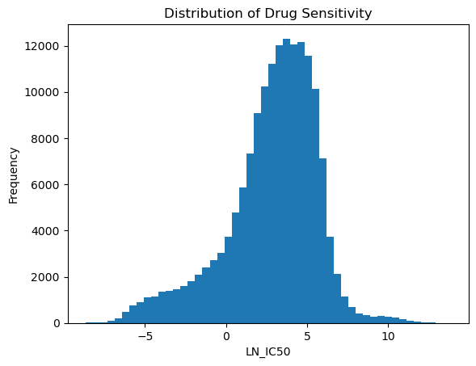
Fig1: Distribution of Drug sensitivity
Top 5 Most Effective Drugs (Lowest LN_IC50):
DRUG_NAME Median_LN_IC50 Median_AUC
185 Romidepsin -5.317812 0.804303
45 Bortezomib -4.906318 0.772874
200 Sepantronium bromide -4.210507 0.174748
70 Docetaxel -3.990660 0.802501
67 Daporinad -3.902214 0.650521

Top 5 Least Effective Drugs (Highest LN_IC50):
DRUG_NAME Median_LN_IC50 Median_AUC
244 ascorbate (vitamin C) 10.449790 0.976723
148 N-acetyl cysteine 9.944135 0.966516
245 glutathione 9.145341 0.974385
243 alpha-lipoic acid 7.705239 0.975969
214 Temozolomide 6.507988 0.979478

Top 5 Most Variable Drugs (Potential Personalized Medicine Candidates):
DRUG_NAME Var_LN_IC50
105 Gemcitabine 8.655067
20 AZD5991 7.614386
67 Daporinad 7.483414
70 Docetaxel 6.486754
36 BI-2536 6.048389

The top five most effective drugs are: Romidepsin, Bortezomib, Sepantronium bromide, Docetaxel, and Daporinad.
The five least effective drugs are: Ascorbate (Vitamin C), N-acetyl cysteine, Glutathione, Alpha-lipoic acid, and Temozolomide.
Four out of five of these compounds (ascorbate, N-acetyl cysteine, glutathione, and alpha-lipoic acid) are antioxidants or dietary supplements. Because they lack localized cytotoxic machinery, they do not induce cell death on their own.
The five most variable drugs are Gemcitabine, AZD5991, Daporinad, Docetaxel, and BI-2536.
The high response variance observed in drugs like Gemcitabine and AZD5991 serves as the perfect statistical springboard for genomic biomarker tracking.
Cancer Cell Line Analysis
Overall Sensitivity by Cancer Type
TCGA_DESC Median_LN_IC50 n_Cell_Lines Sample_Quality
CLL 1.553044 2 ⚠ Very small sample
LAML 2.043654 24 Robust
ALL 2.063221 26 Robust
DLBC 2.096066 33 Robust
LCML 2.162442 10 Moderate
MM 2.470976 16 Moderate
ACC 2.819815 1 ⚠ Very small sample
NB 2.851345 32 Robust
MB 2.939177 4 ⚠ Very small sample
HNSC 3.119146 36 Robust

LAML (median LN_IC50 = 2.04), ALL (median LN_IC50 = 2.06) and DLBC (median LN_IC50 = 2.096) are the most drug-sensitive cancer types. PAAD (median LN_IC50 = 4.17), MESO (median LN_IC50 = 3.86), UCEC (median LN_IC50 = 3.84) and LIHC (median LN_IC50 = 3.83) are the most drug-resistant
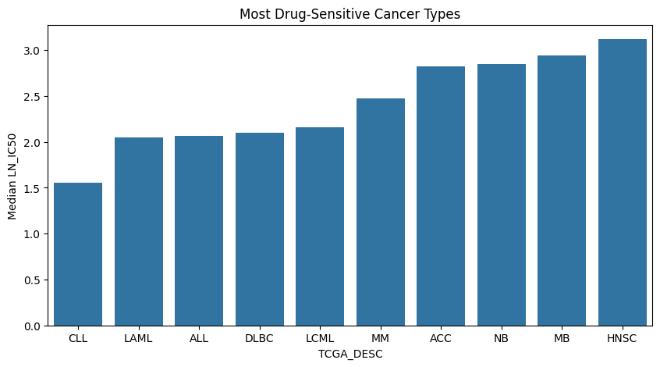
Fig2: Most drug-sensitive cancer types across all drugs
Cancer types like LAML, ALL, DLBC, LCML, and MM are the most drug-sensitive cancer types. They are blood cancers. They show lower LN_IC50 values. They usually respond better to many targeted agents, have faster proliferation and have greater dependence on oncogenic pathways. So seeing them among the most sensitive is biologically possible.
Overall drug sensitivity by cancer type was assessed using median LN_IC50 values across all tested compounds. Hematologic malignancies, including LAML, ALL, DLBC, and LCML, showed the lowest median LN_IC50 values, indicating increased drug sensitivity. In contrast, PAAD, UCEC, and LIHC exhibited the highest median LN_IC50 values, consistent with clinically resistant tumour types. Cancer types with very small sample sizes (e.g., CLL and ACC) were interpreted cautiously.
Cancer-Type-Selective Drug Responses

DRUG_NAME | Min_LN_IC50_x | Max_LN_IC50_x | Range | Most_Sensitive_Cancer | Min_LN_IC50_y | Least_Sensitive_Cancer | Max_LN_IC50_y | TARGET_PATHWAY_x | TARGET_PATHWAY_y | TARGET_PATHWAY
Dasatinib | -7.024216 | 3.477284 | 10.501501 | LCML | -7.024216 | SKCM | 3.477284 | Other, kinases | Other, kinases | Other, kinases
Nilotinib | -4.954357 | 4.167787 | 9.122144 | LCML | -4.954357 | MESO | 4.167787 | ABL signaling | ABL signaling | ABL signaling
Gemcitabine | -5.156275 | 3.206833 | 8.363108 | CLL | -5.156275 | UCEC | 3.206833 | DNA replication | DNA replication | DNA replication
AZD5991 | -1.796554 | 6.223226 | 8.019780 | MM | -1.796554 | PAAD | 6.223226 | Apoptosis regulation | Apoptosis regulation | Apoptosis regulation
Bosutinib | -3.942034 | 3.904068 | 7.846102 | LCML | -3.942034 | GBM | 3.904068 | Other, kinases | Other, kinases | Other, kinases
Tozasertib | -2.161219 | 5.493971 | 7.655190 | DLBC | -2.161219 | PAAD | 5.493971 | Mitosis | Mitosis | Mitosis

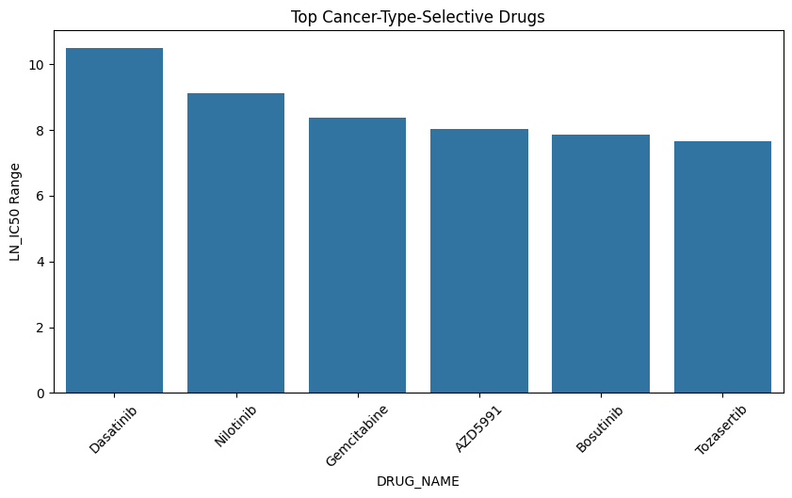
Fig3: Top Cancer type selective drugs
Dasatinib, Nilotinib and Bosutinib drugs selectively achieve better responses in LCML cancer by targeting the kinases and ABL signalling pathways, respectively, but they don't work better in SKCM, MESO and GBM cancers. Likewise, AZD5991 selectively works for MM cancers by targeting the DNA replication pathways. Tozasertib selectively work for DLBC by targeting the mitosis pathway.
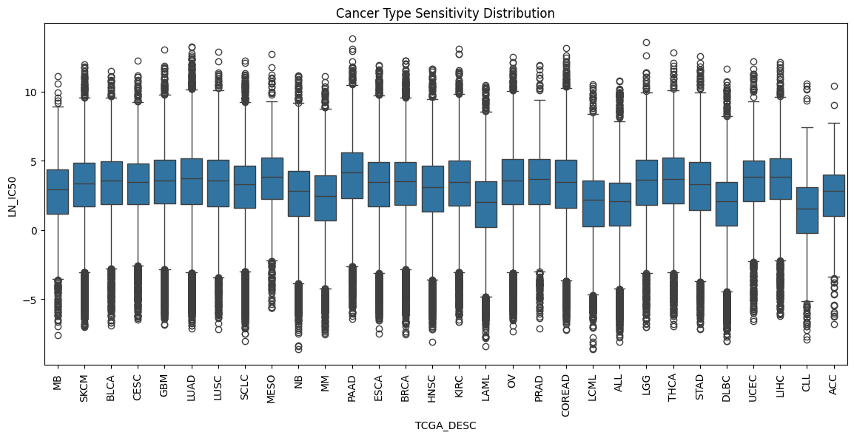
Fig4: Cancer type sensitivity distribution
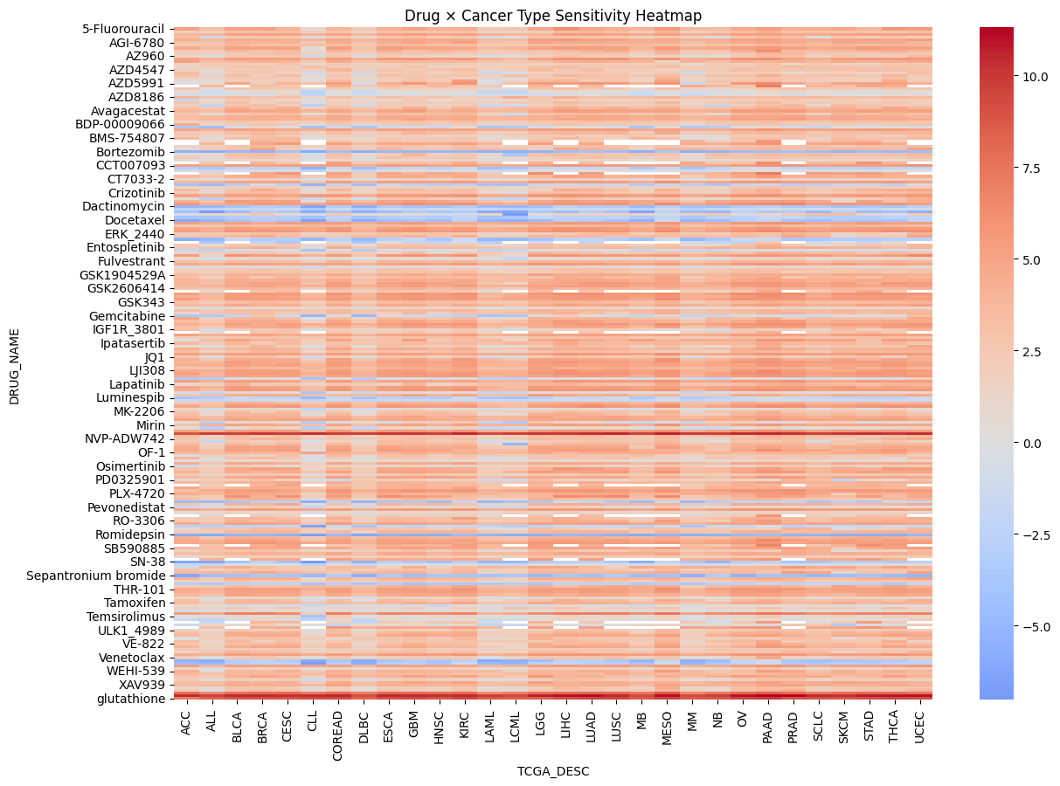
Fig5: Drug-Cancer type sensitivity heatmap
Genomic & Molecular Influences on Drug Response
LN_IC50 vs AUC Correlation
Pearson correlation r = 0.756 indicates a strong positive relationship. Spearman correlation ρ = 0.776 also confirms strong monotonic agreement. LN_IC50 and AUC showed strong positive correlation (Pearson r = 0.756; Spearman ρ = 0.776; n = 5,000 sampled observations), indicating that both metrics capture related aspects of drug sensitivity. The correlation was not perfect, likely because AUC summarises the entire dose–response curve, whereas IC50 reflects only the midpoint response concentration.
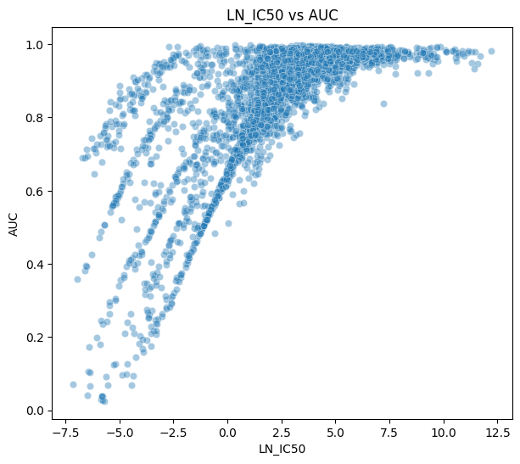
Fig6: LN_IC50vs AUC
MSI Status
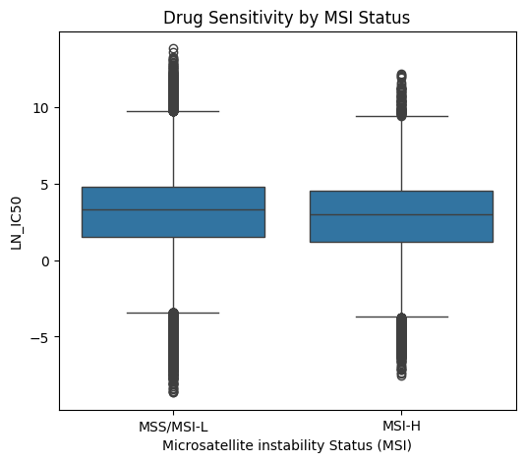
Fig7: Drug sensitivity by MSI Status
Mann–Whitney was used as LN_IC50 distributions may not be normal, and it is robust to skewness/outliers. The p-value = 3.8078404168508164e-32
which is <0.001, so MSI-H tumours are significantly different. MSI-H tumours exhibited significantly greater drug sensitivity (lower LN_IC50 median) than MSS/MSI-L tumours (median LN_IC50 = 2.997 vs 3.293; Mann–Whitney U p < 0.001).
MSI-H-Selective Drugs

DRUG_NAME | Delta_LN_IC50 (MSI-H - MSS median) | p_value | bonferroni_p | TARGET_PATHWAY
Methotrexate | -2.427830 | 2.323654e-05 | 0.005716 | DNA replication
VE821 | -1.368650 | 1.428942e-04 | 0.035152 | Genome integrity
GSK2110183B | -1.248714 | 1.319419e-04 | 0.032458 | PI3K/MTOR signaling
5-Fluorouracil | -1.096814 | 2.829482e-05 | 0.006961 | Other
AZD6738 | -1.075234 | 2.125003e-05 | 0.005228 | Genome integrity
Oxaliplatin | -0.904644 | 3.365266e-06 | 0.000828 | DNA replication
Ipatasertib | -0.870852 | 3.004201e-05 | 0.007390 | PI3K/MTOR signaling
Uprosertib | -0.855349 | 1.740440e-07 | 0.000043 | PI3K/MTOR signaling
Afuresertib | -0.598986 | 8.640339e-05 | 0.021255 | PI3K/MTOR signaling

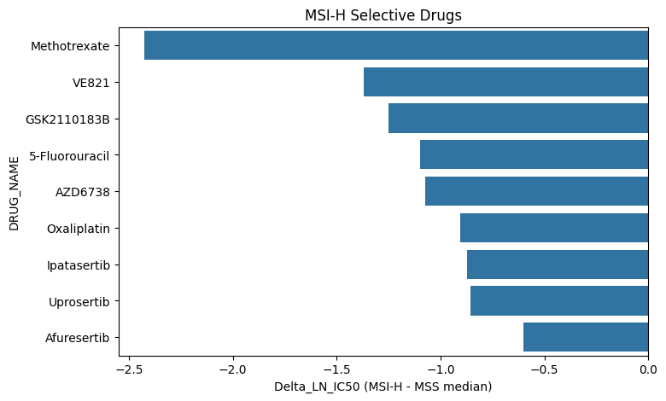
Fig8: MSI-H Selective drugs
After Bonferroni correction across 233 drugs, 10 compounds showed significant MSI-H selectivity, particularly agents targeting DNA replication and genome integrity pathways. This is biologically consistent with the defective mismatch repair and elevated replication stress characteristic of MSI-H tumours.
Growth Properties
Suspension-growing cell lines demonstrated significantly greater drug sensitivity than adherent cell lines (median LN_IC50 = 2.44 vs 3.52; Mann–Whitney U p < 0.001).
Drugs Preferentially Effective in Suspension Cells
DRUG_NAME | Delta_LN_IC50 | p_value | bonferroni_p | TARGET_PATHWAY
AZD5991 | -4.037533 | 6.857126e-28 | 1.686853e-25 | Apoptosis regulation
BI-2536 | -3.305943 | 3.062716e-38 | 7.534281e-36 | Cell cycle
ABT737 | -3.120846 | 5.073589e-37 | 1.248103e-34 | Apoptosis regulation
Alisertib | -3.106905 | 6.535422e-22 | 1.607714e-19 | Mitosis
Cytarabine | -3.064477 | 1.429757e-23 | 3.517201e-21 | Other
Navitoclax | -3.029453 | 9.917882e-34 | 2.439799e-31 | Apoptosis regulation
Methotrexate | -2.906178 | 6.661953e-11 | 1.638841e-08 | DNA replication
Gemcitabine | -2.848927 | 3.327317e-20 | 8.185199e-18 | DNA replication
JQ1 | -2.694382 | 5.051174e-33 | 1.242589e-30 | Chromatin other
Tozasertib | -2.586193 | 1.679244e-11 | 4.130941e-09 | Mitosis

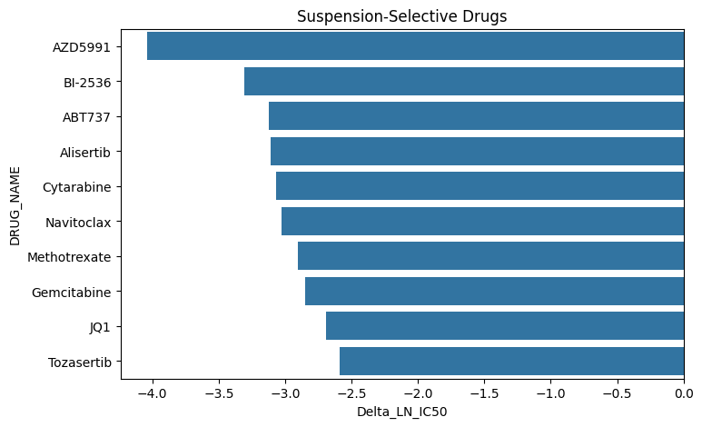
Fig9: Suspension-selective drugs
Drugs preferentially active in suspension cells included AZD5991, BI-2536, ABT737, Alisertib, Navitoclax, Cytarabine, and Methotrexate, all of which have established relevance in hematologic malignancies. These drugs mainly target DNA replication, apoptosis, the cell cycle and mitosis. However, this effect is likely confounded by cancer type composition, as suspension-growing lines predominantly represent hematologic cancers, whereas adherent lines are mainly derived from solid tumours.
Genomic, transcriptomic and epigenomic influence on drug response
CNA:
CNA available median: 3.269899
No CNA median: 3.508225
P-value: 0.007392764007602847
Delta median: -0.23832599999999982
Gene Expression:
expr_yes median: 3.283111
expr_no median: 2.830496
P-value: 2.912858913302848e-30
Delta: 0.45261499999999977
Methylation:
methylation_yes median: 3.272621
methylation_no median: 3.211147
P-value: 0.3424236592391552
Delta: 0.06147400000000003
Availability of CNA and gene expression data was significantly associated with LN_IC50 differences (Mann–Whitney U p < 0.01), although effect sizes were small (delta median < 0.5 LN_IC50 units). These associations likely reflect cancer type composition bias rather than direct causal effects of genomic data availability on drug response. However, Methylation does not have any effect on drug response (p=0.342).
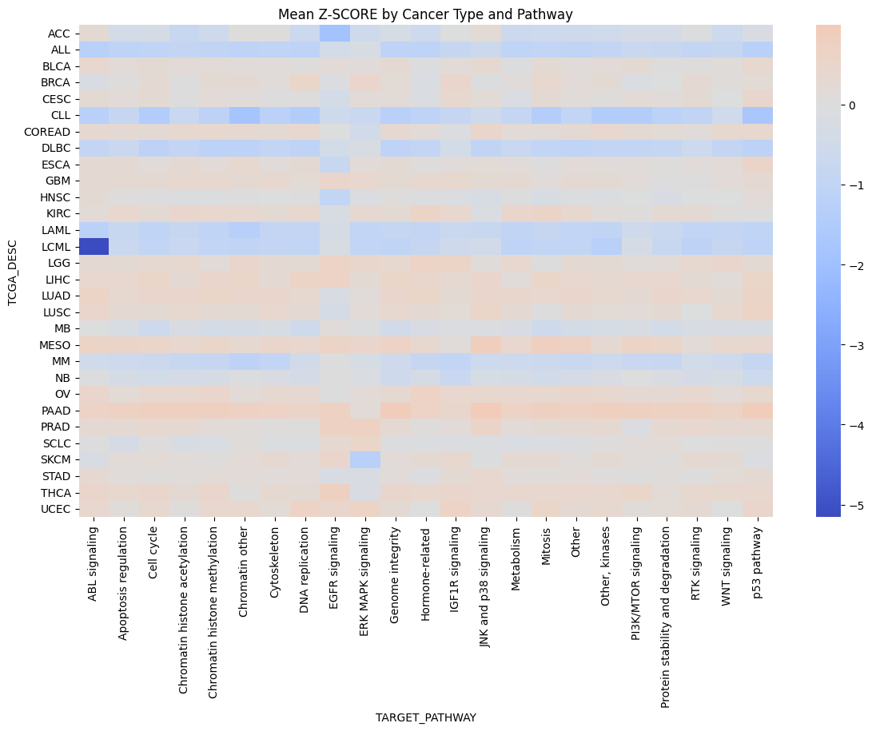
Fig10: Mean Z-Score heatmap (cancer type × target pathway)

Correlation analysis demonstrated strong concordance between LN_IC50 and AUC measurements, while pathway-level heatmaps highlighted lineage-specific drug sensitivity patterns across cancer types.
Findings
- Hematologic malignancies demonstrated the greatest overall drug sensitivity. Cancer types such as LAML, ALL, DLBC, and MM exhibited the lowest median LN_IC50 values, aligning with their known clinical responsiveness to chemotherapy and targeted therapies.
- Pancreatic adenocarcinoma (PAAD) emerged as the most drug-resistant cancer type, with the highest median LN_IC50 value (4.17). This observation is consistent with the aggressive nature of pancreatic cancer and its limited therapeutic responsiveness in clinical settings.
- MEK inhibitors displayed strong melanoma-specific activity. Trametinib and PD0325901 were particularly selective for SKCM cell lines, reflecting the frequent activation of the MAPK pathway through BRAF and RAS mutations in melanoma.
- MSI-H tumors showed increased drug sensitivity compared with MSS/MSI-L tumors, especially toward DNA-damaging agents and ATR inhibitors. These findings support the biological vulnerability of mismatch repair–deficient tumors to replication stress and DNA damage response targeting.
- Drugs targeting mitosis and DNA replication pathways were among the most broadly potent compounds across cancer types, highlighting the dependence of rapidly proliferating cancer cells on these core cellular processes.
- Antioxidant compounds such as Vitamin C, N-acetylcysteine (NAC), and glutathione exhibited the highest IC50 values, indicating minimal cytotoxic activity. Their inclusion illustrates the broad pharmacologic scope of the GDSC screening platform.
Limitations
- The CNA, Gene Expression, and Methylation variables represent only the availability of molecular profiling data rather than actual quantitative genomic measurements. Access to continuous genomic features would allow more detailed mechanistic and biomarker analyses.
- Certain cancer types had very limited sample sizes, including CLL (n=2), ACC (n=1), and MB (n=4). Results for these groups should therefore be interpreted cautiously.
- Observed associations involving growth properties or genomic data availability are likely influenced by confounding due to cancer type composition rather than direct biological effects.
- All analyses were performed using in vitro cancer cell line models. Drug responses observed in cell lines may not fully translate to patient tumors or clinical outcomes.
- Some IC50 estimates may be less reliable because they were extrapolated beyond the experimentally tested drug concentration ranges.

